Loan Management System

**Problem statement**

Loan management system manages the process of originating Loan orders, modify/update and cancellation of loan related information. The Loan information accounts for the loan number, loan amount, loan term, borrower information, property information, status, loan management fees, origination date, origination account, lien information, legal documents and loan history.

The main components that make up the loan are as follows:

1. Borrower information: details of the person or party borrowing the loan amount
2. Property information: details of the property for which loan is originated
3. Lien information: information related to the taxes and bill amounts liable to be paid to various taxing authorities
4. Legal documents: legal documents related to the property and ownership related information

The scope of this project is to deploy an application using the latest state-of-the-art technology stack on Google Cloud platform Anthos KF.

**Skills Used**

|  |  |
| --- | --- |
| **Tower Name** | **Topics** |
| Frontend | Angular |
| Backend – Java | Core Java 8  Spring Boot  Microservices |
| Database | MySQL |

**Screenshot of Projects:**

* This is the Starting UI page of the Website.

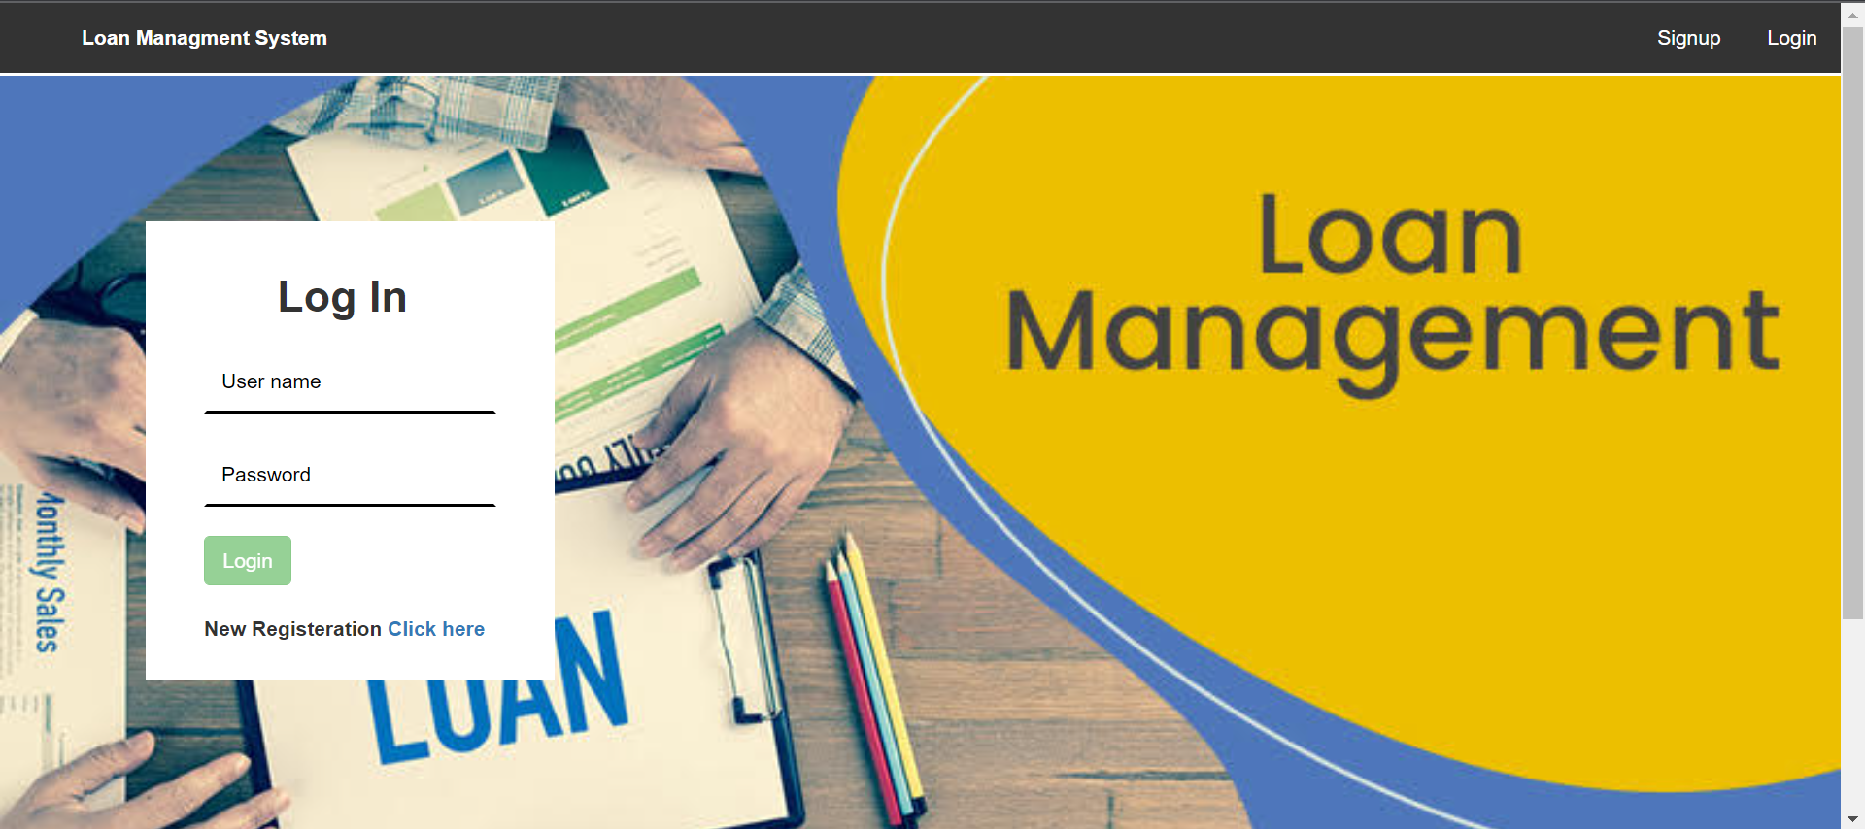

* If you are new user click on signup to register.

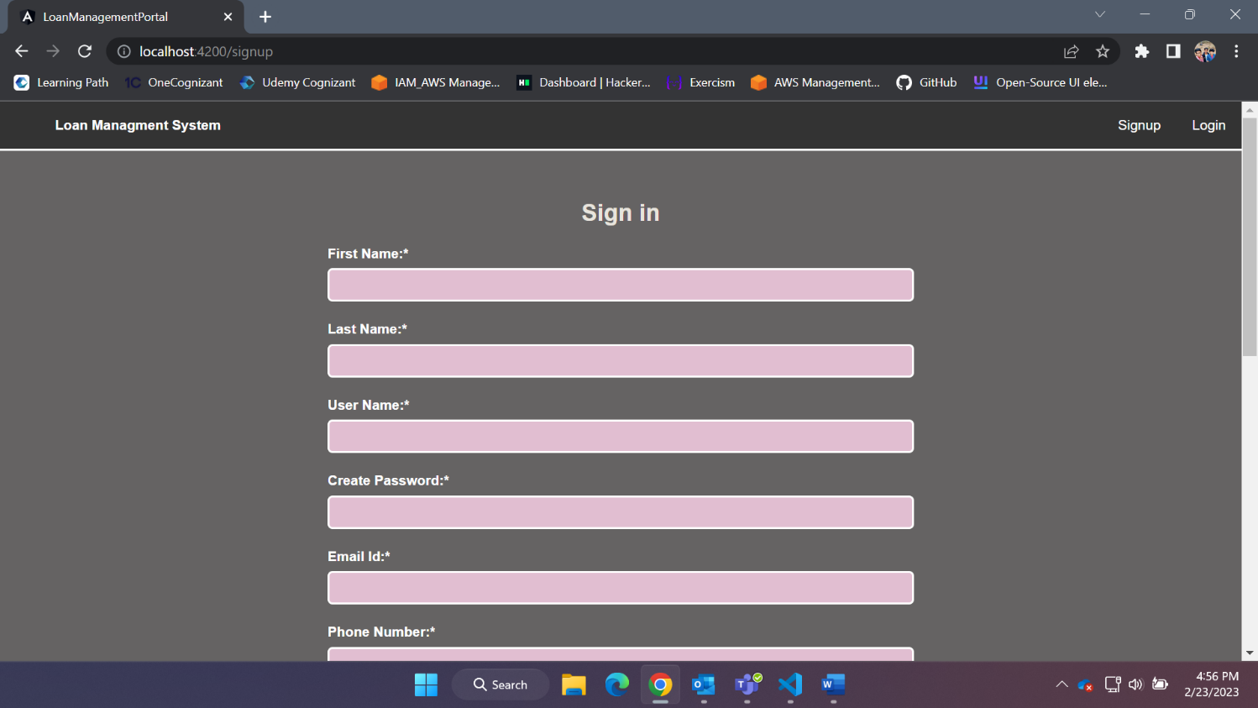

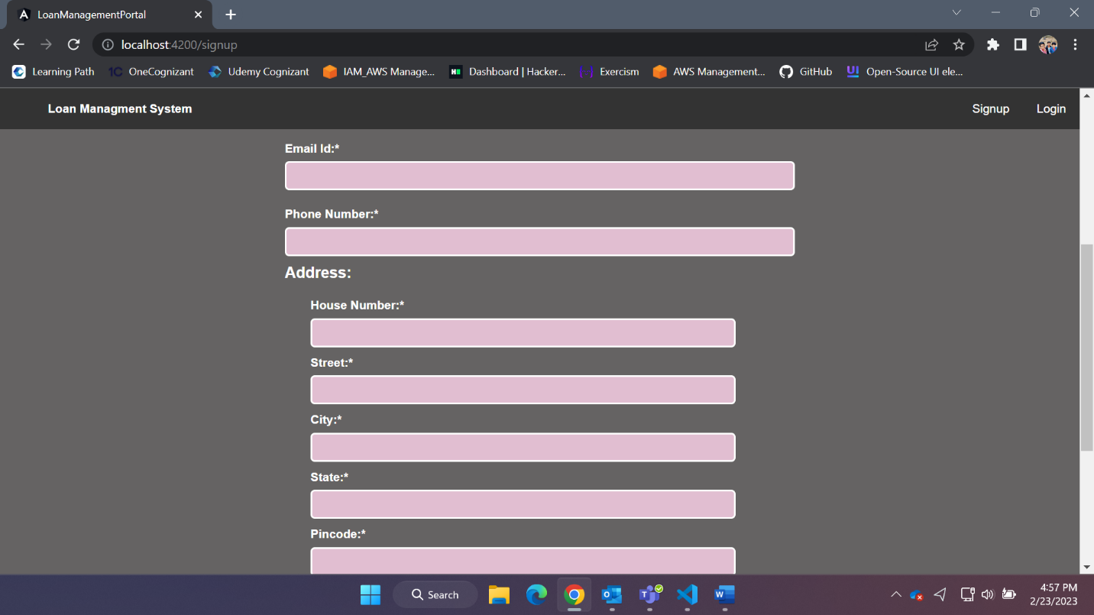

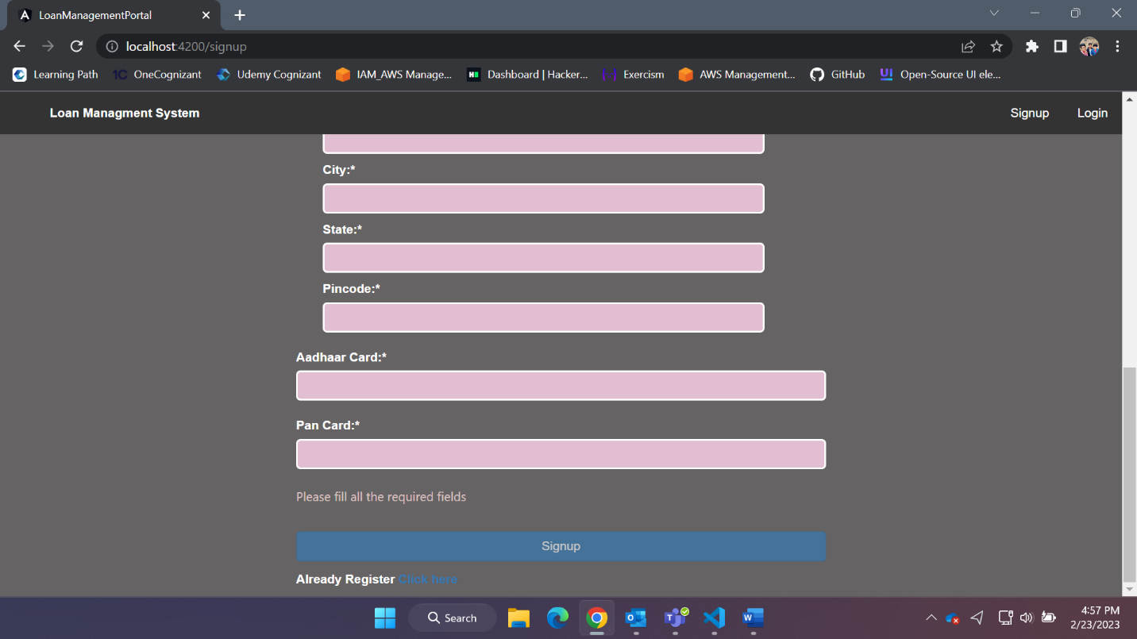

* After Signing up and Login to the Home page. You will be login has a User Role.

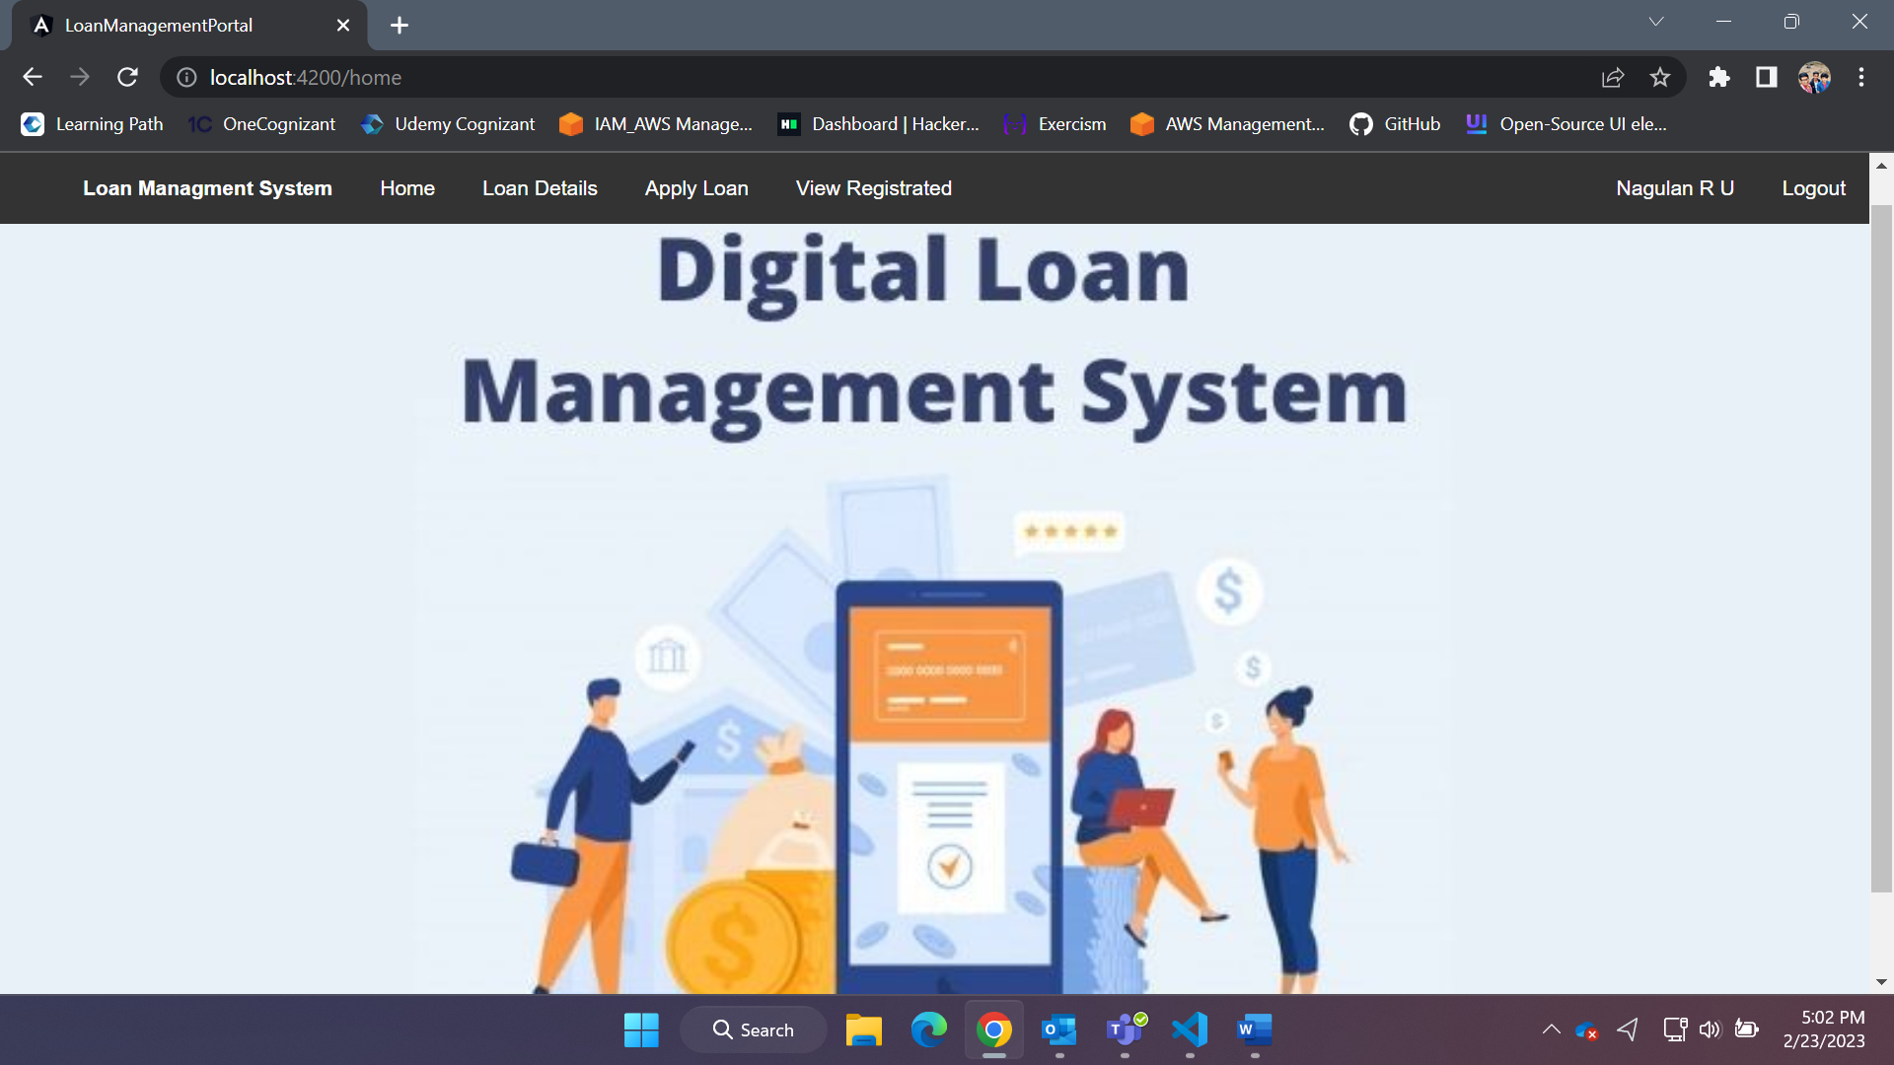

* As Role User they can
  1. See loan details

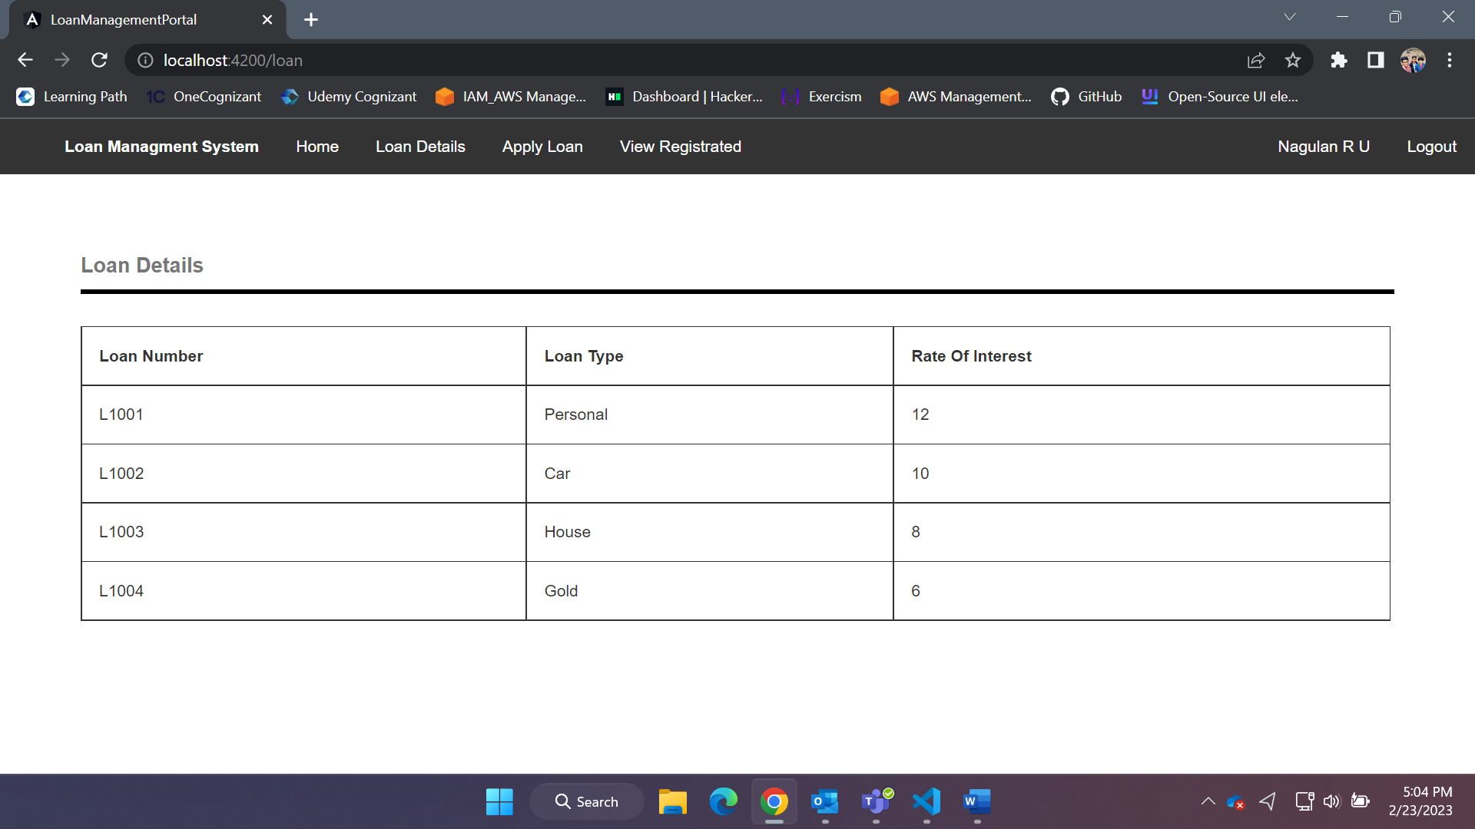

* 1. Apply for Loan

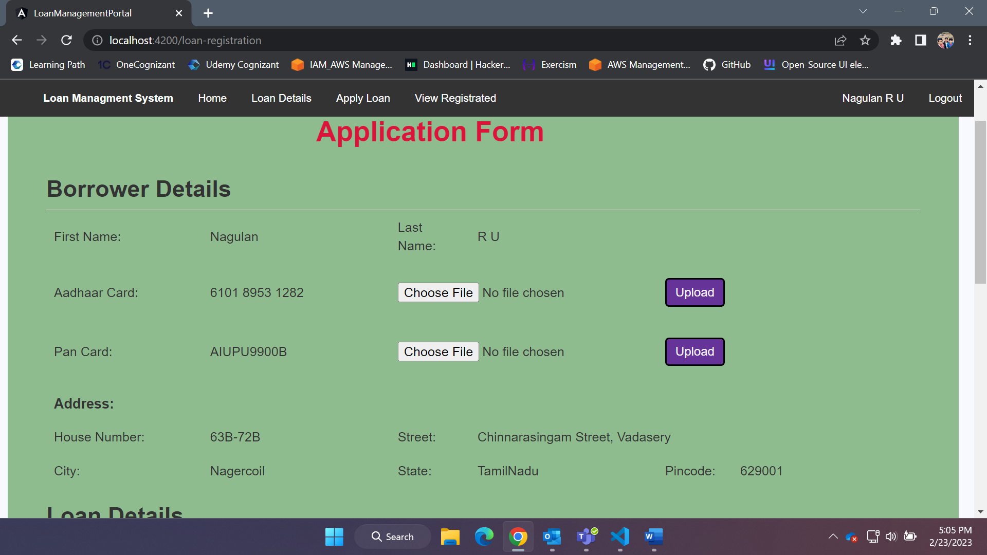

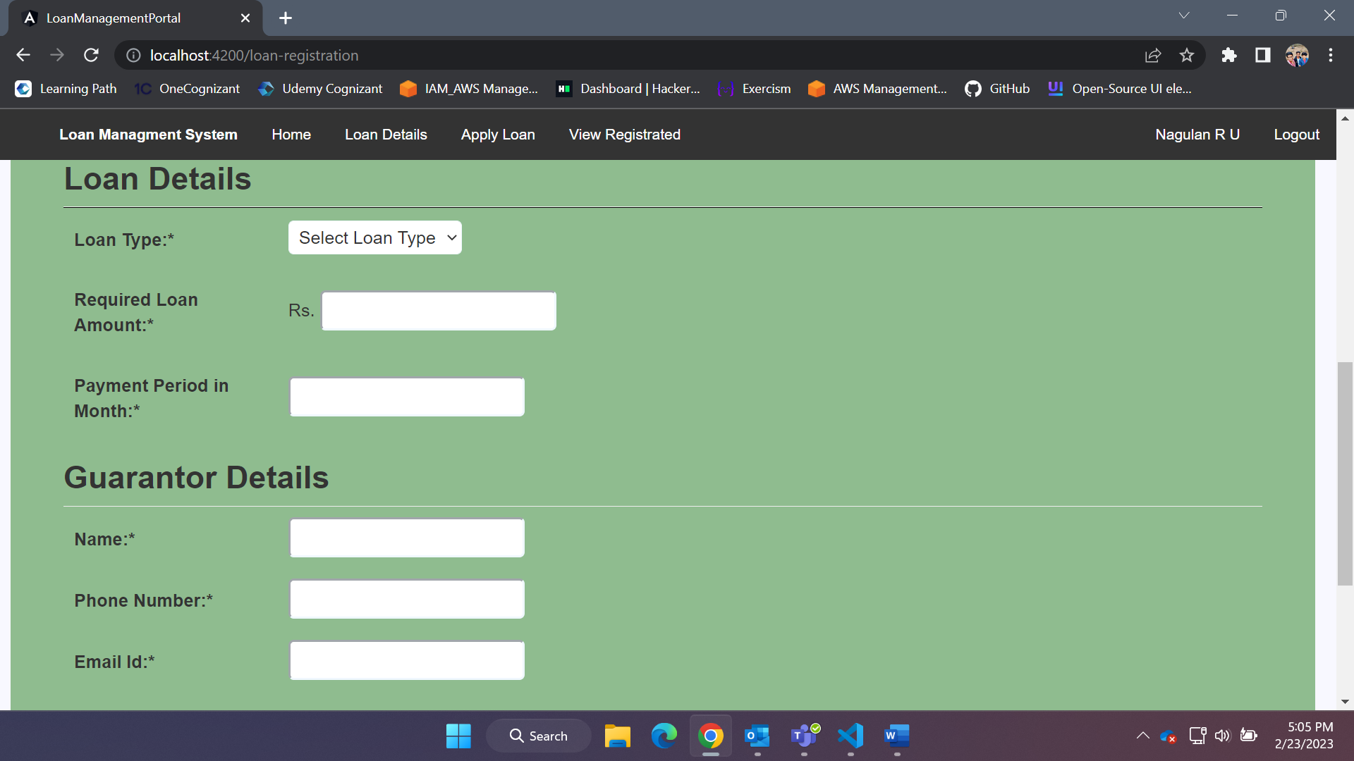

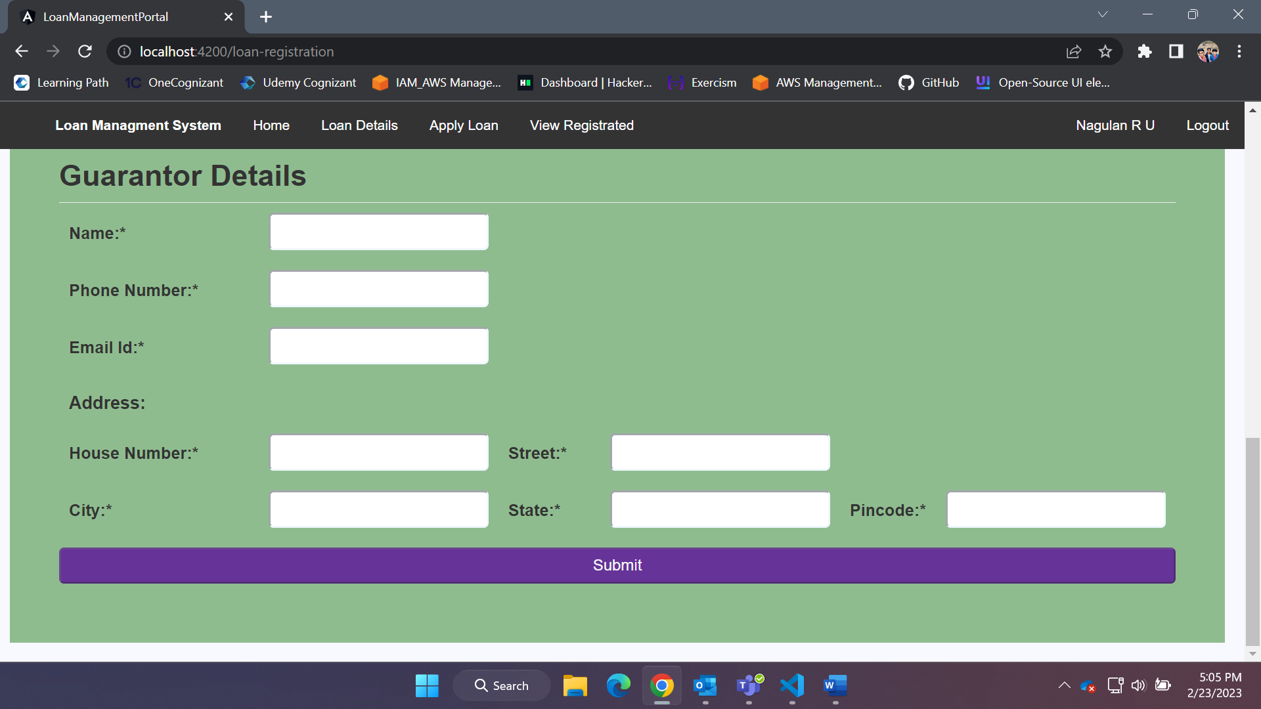

* 1. View their Applied Loan Details

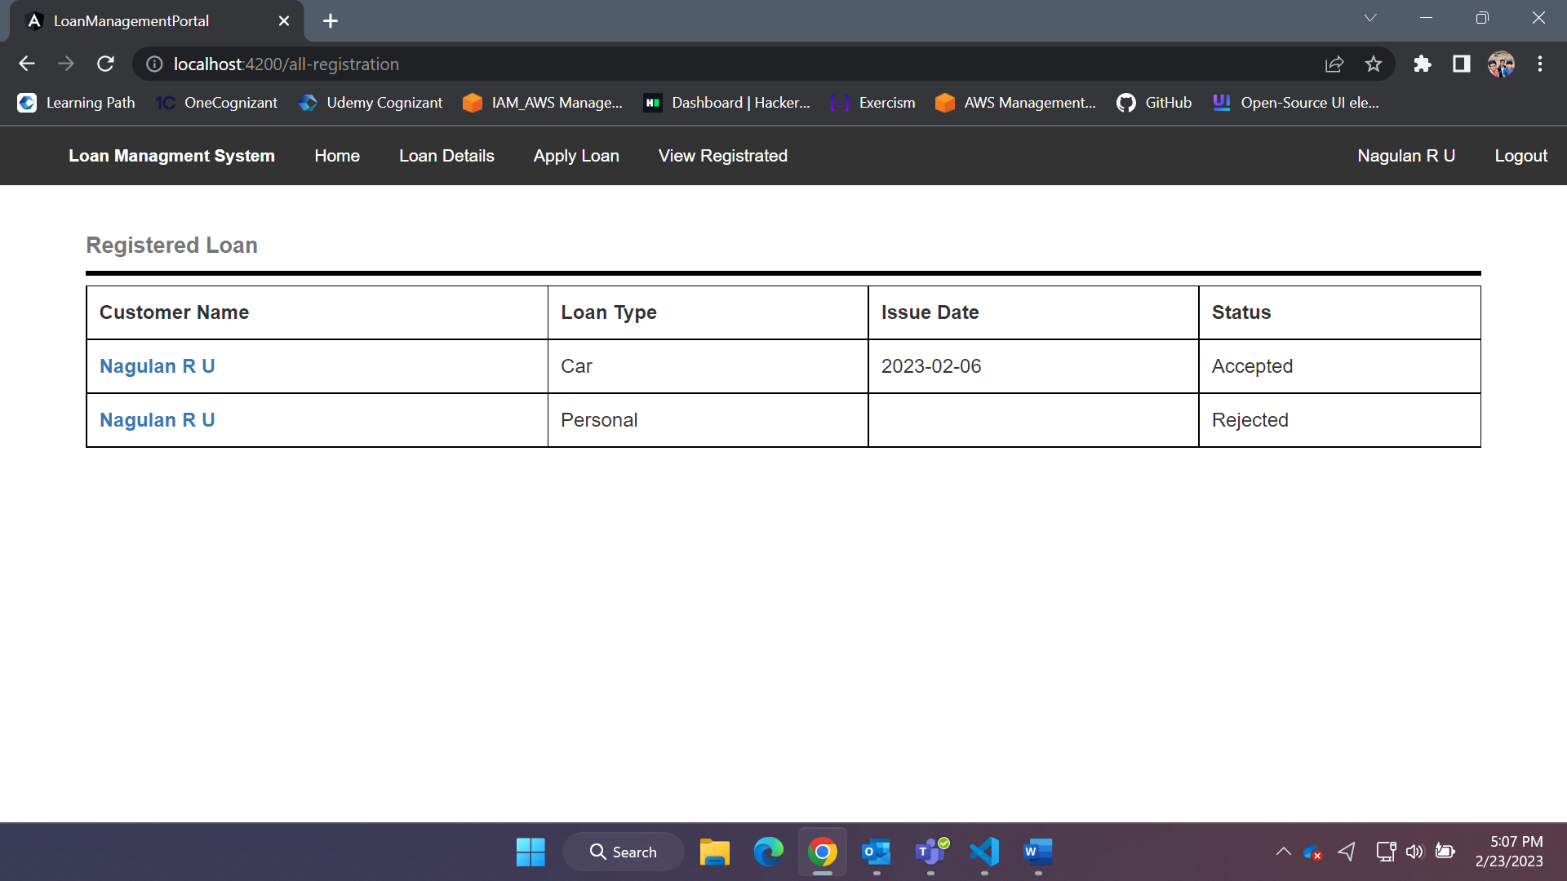

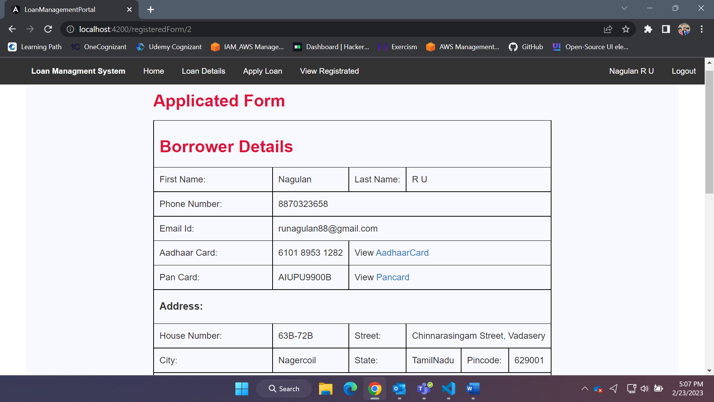

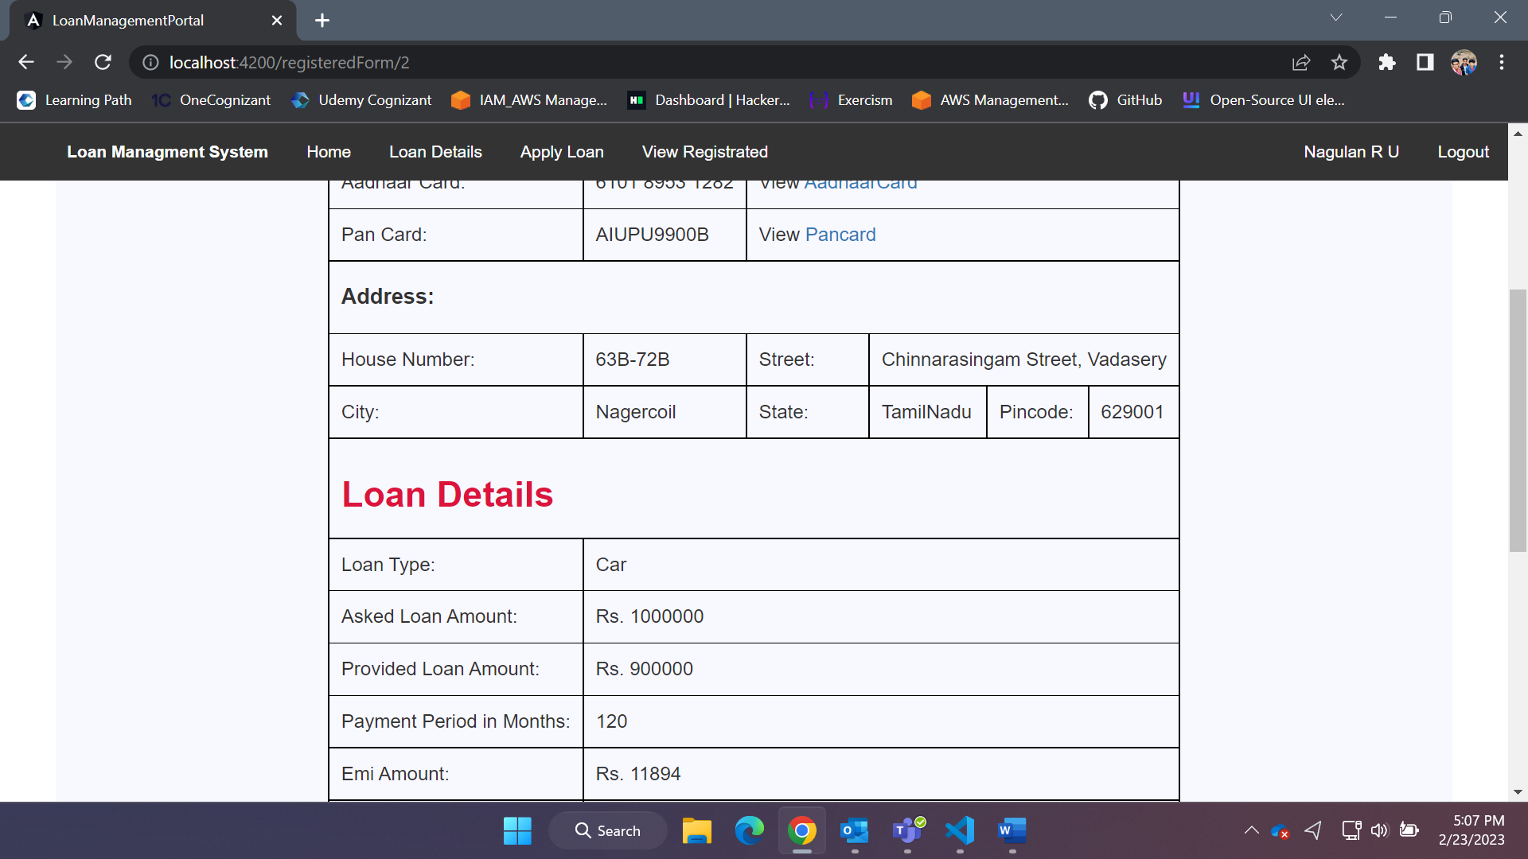

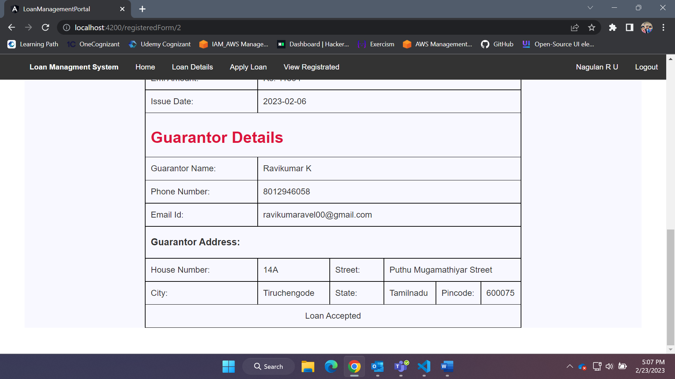

1. The loan applied will be accepted or rejected by the Admin.

* If you login as Role Admin. You can see
  1. In the loan details page Admin can Add, Edit and Delete the loan Detail.

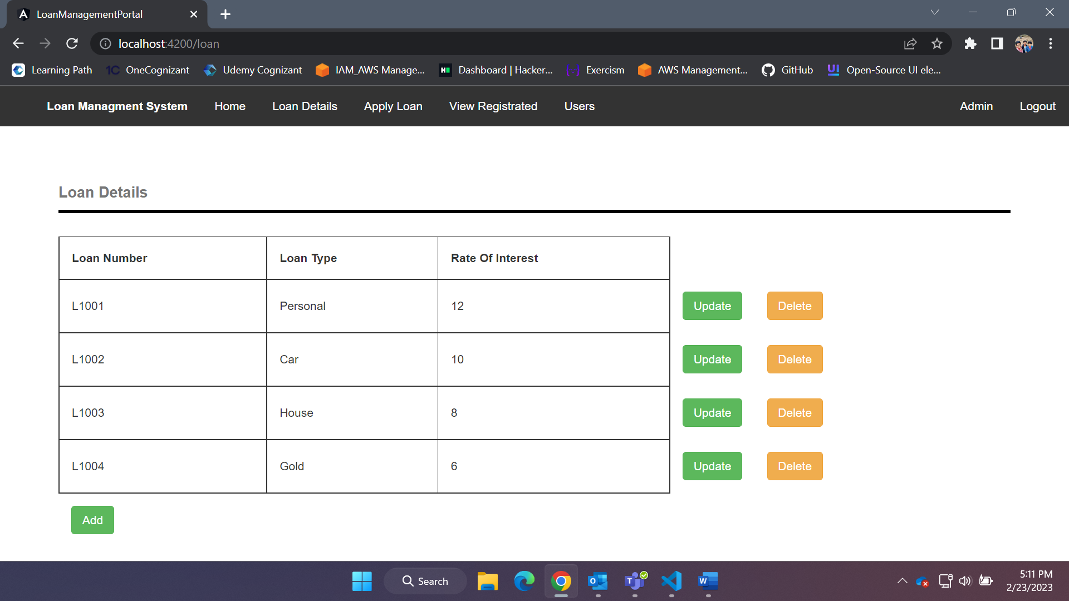

Add Page:

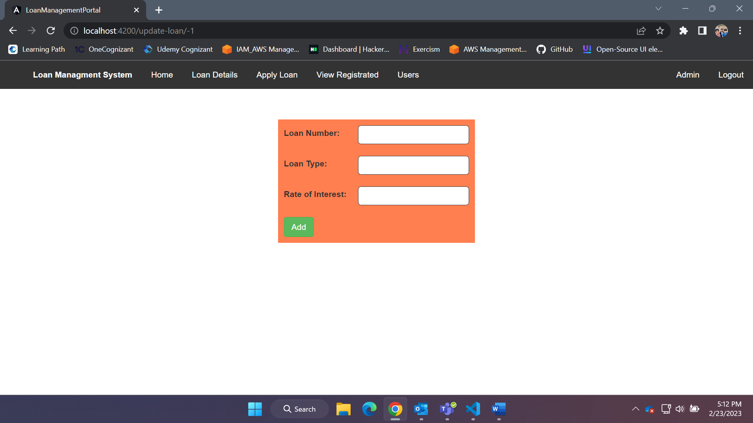

Update Page:

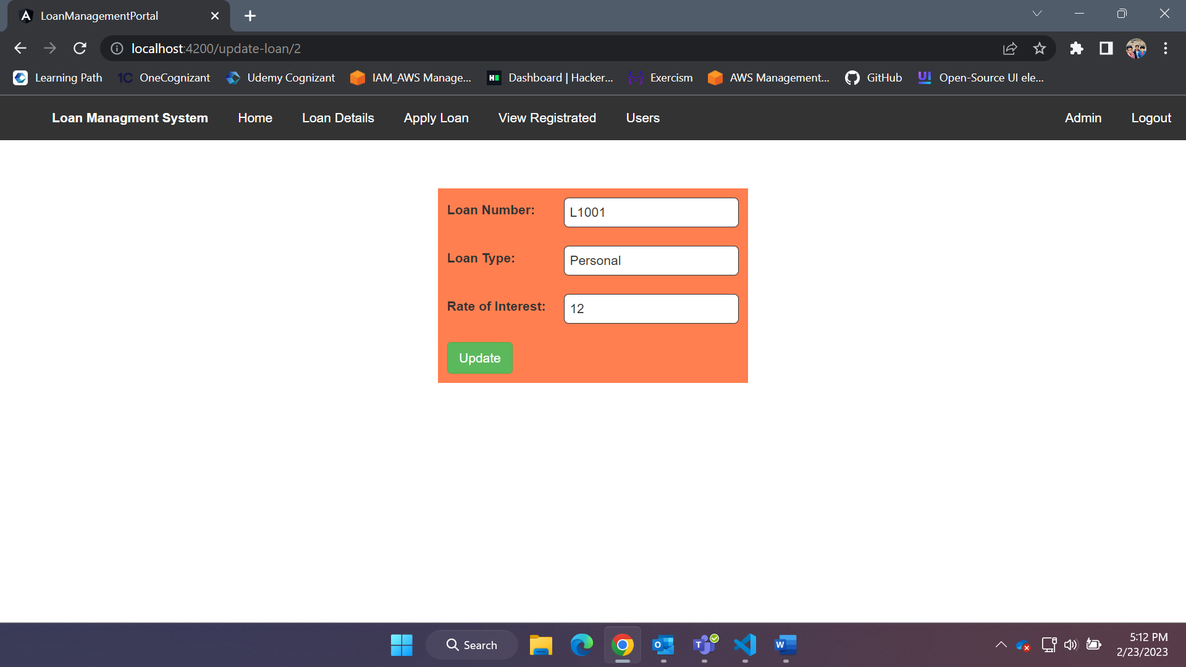

* 1. Apply Loan page you can provide loan for any of the user.

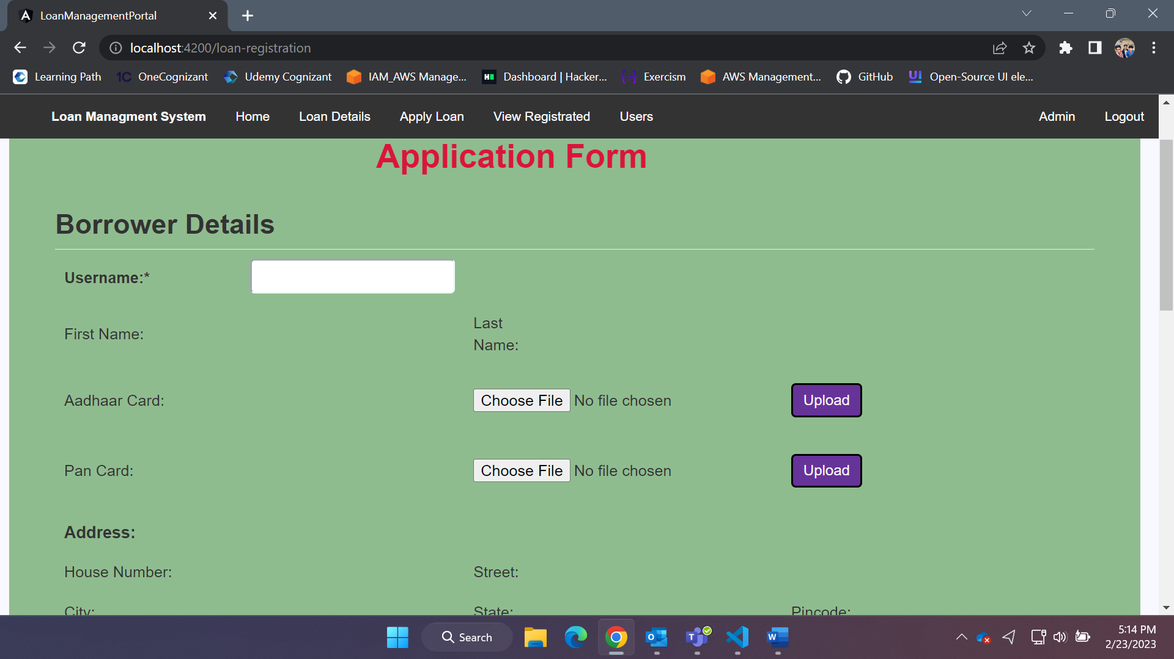

* 1. In View Registrated page Admin can see all the loan that are applied and there status. If the status in pending Admin can reject or accept the loan the user applied.

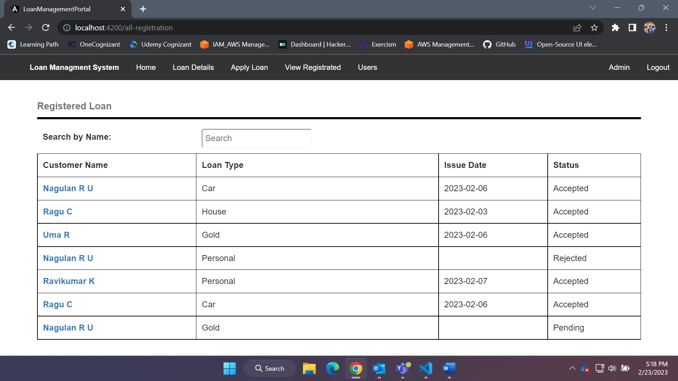

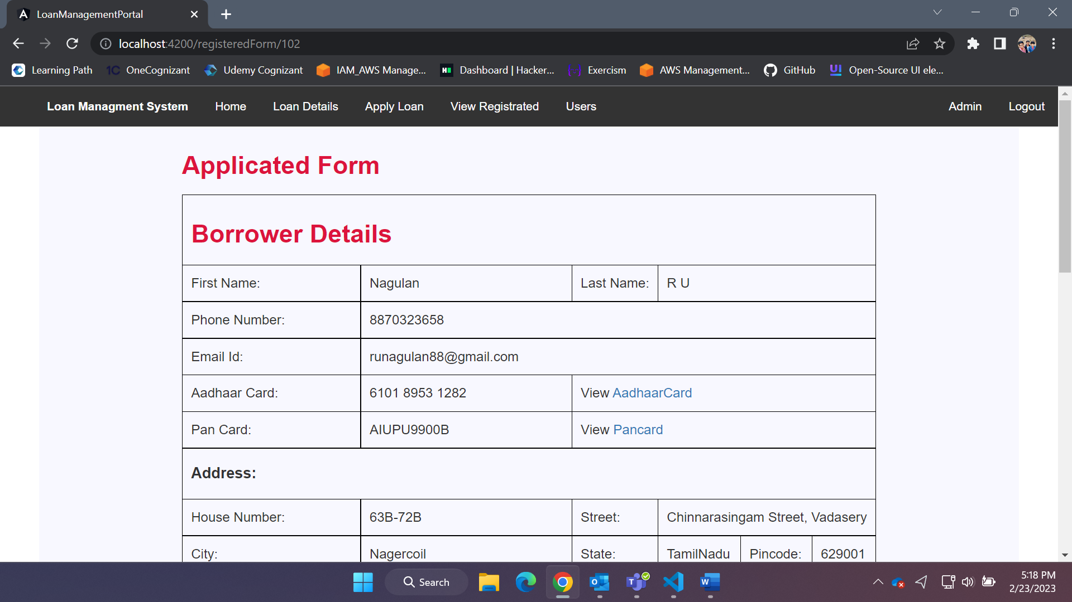

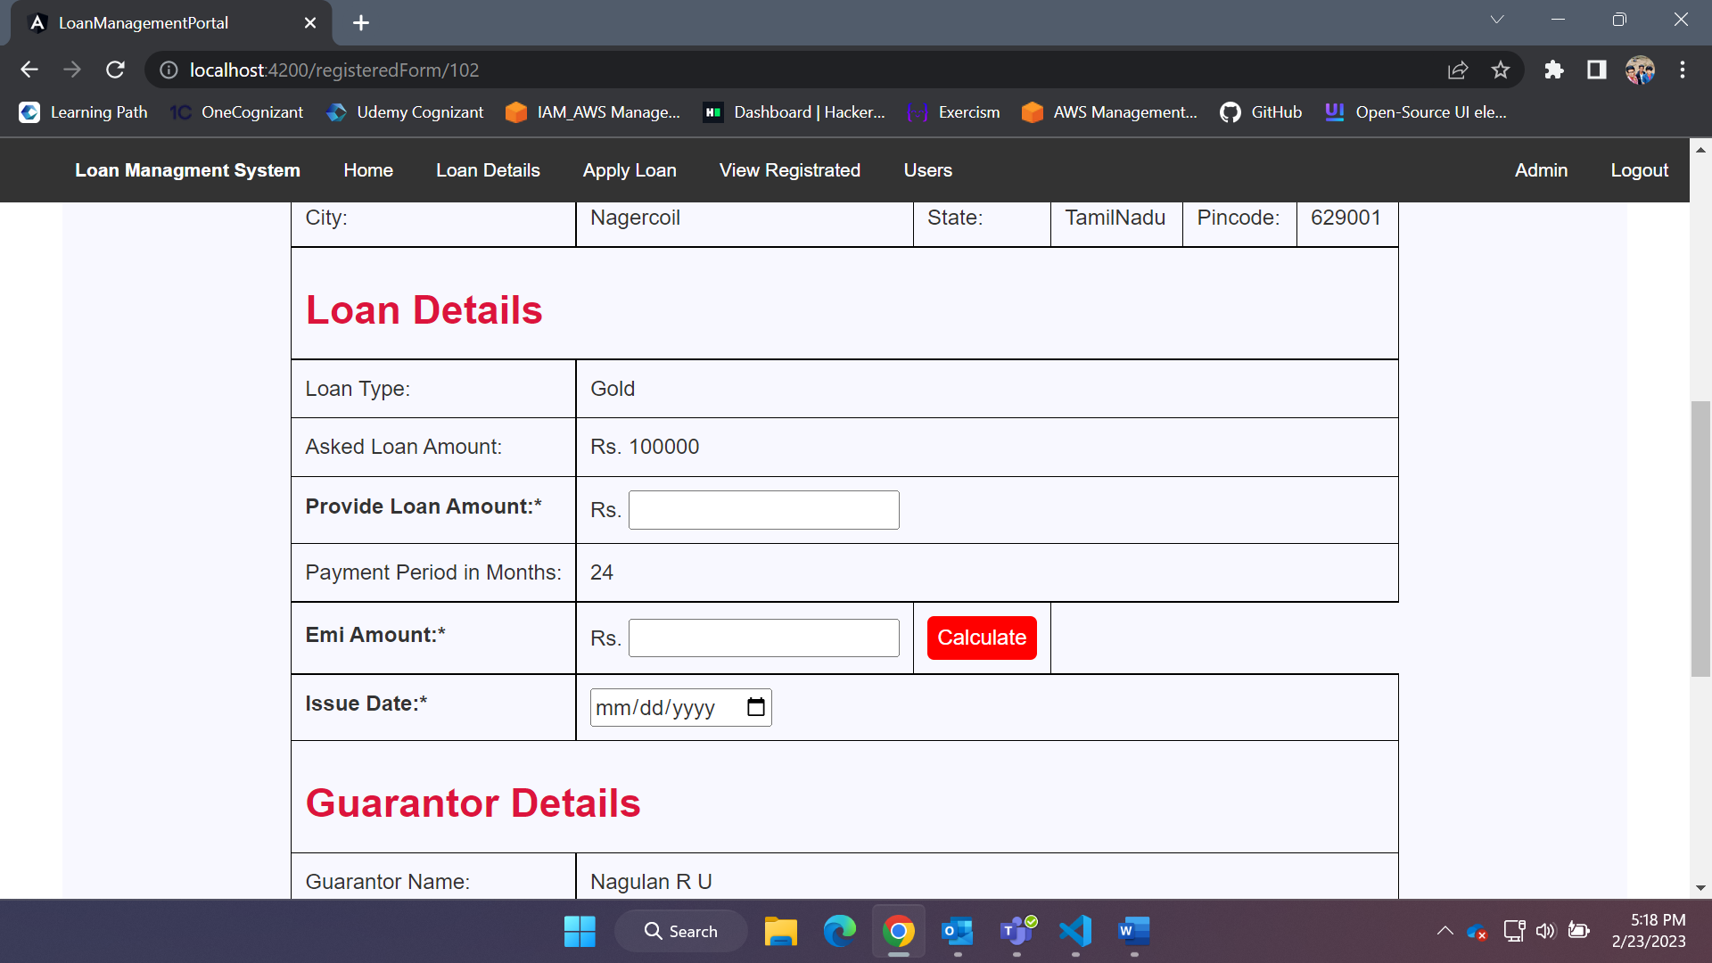

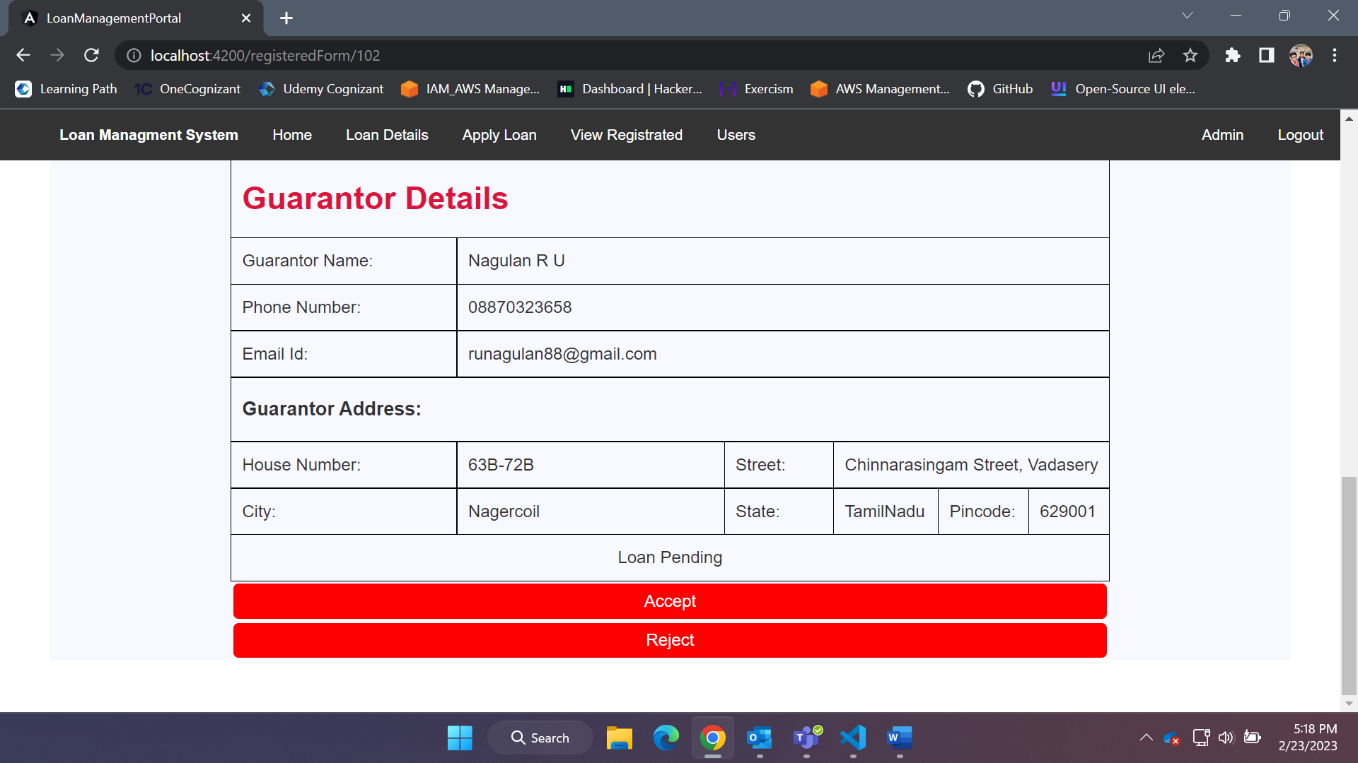

1. Admin can see all the users and there details

